Game Market

1709853E-II20-0033, Yulei Wang

[wangyuleinihao@126.com](mailto:wangyuleinihao@126.com)

1709853E-II20-0033, Jianwen Yuan

[wangyuleinihao@126.com](mailto:wangyuleinihao@126.com)

April 17th, 2018

Menu:

* Location: can locate automatically or choose the location (country, area etc.) by the user
* Account: can log in, sign up, and find or reset your password
* Cart: can add the goods you want to buy into the cart, can see what you have bought, the system also can recommend the potential good you may like.
* Favorites: can add the good to your favorites
* About: you can seek help if you have some problems or you can know more about our website.

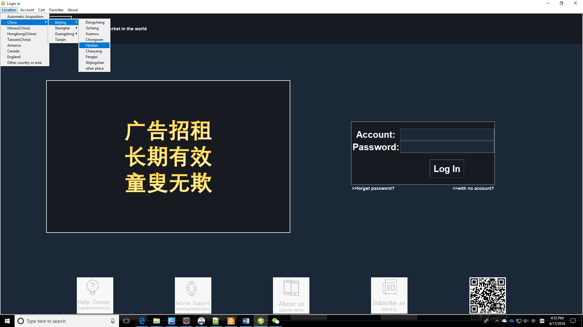

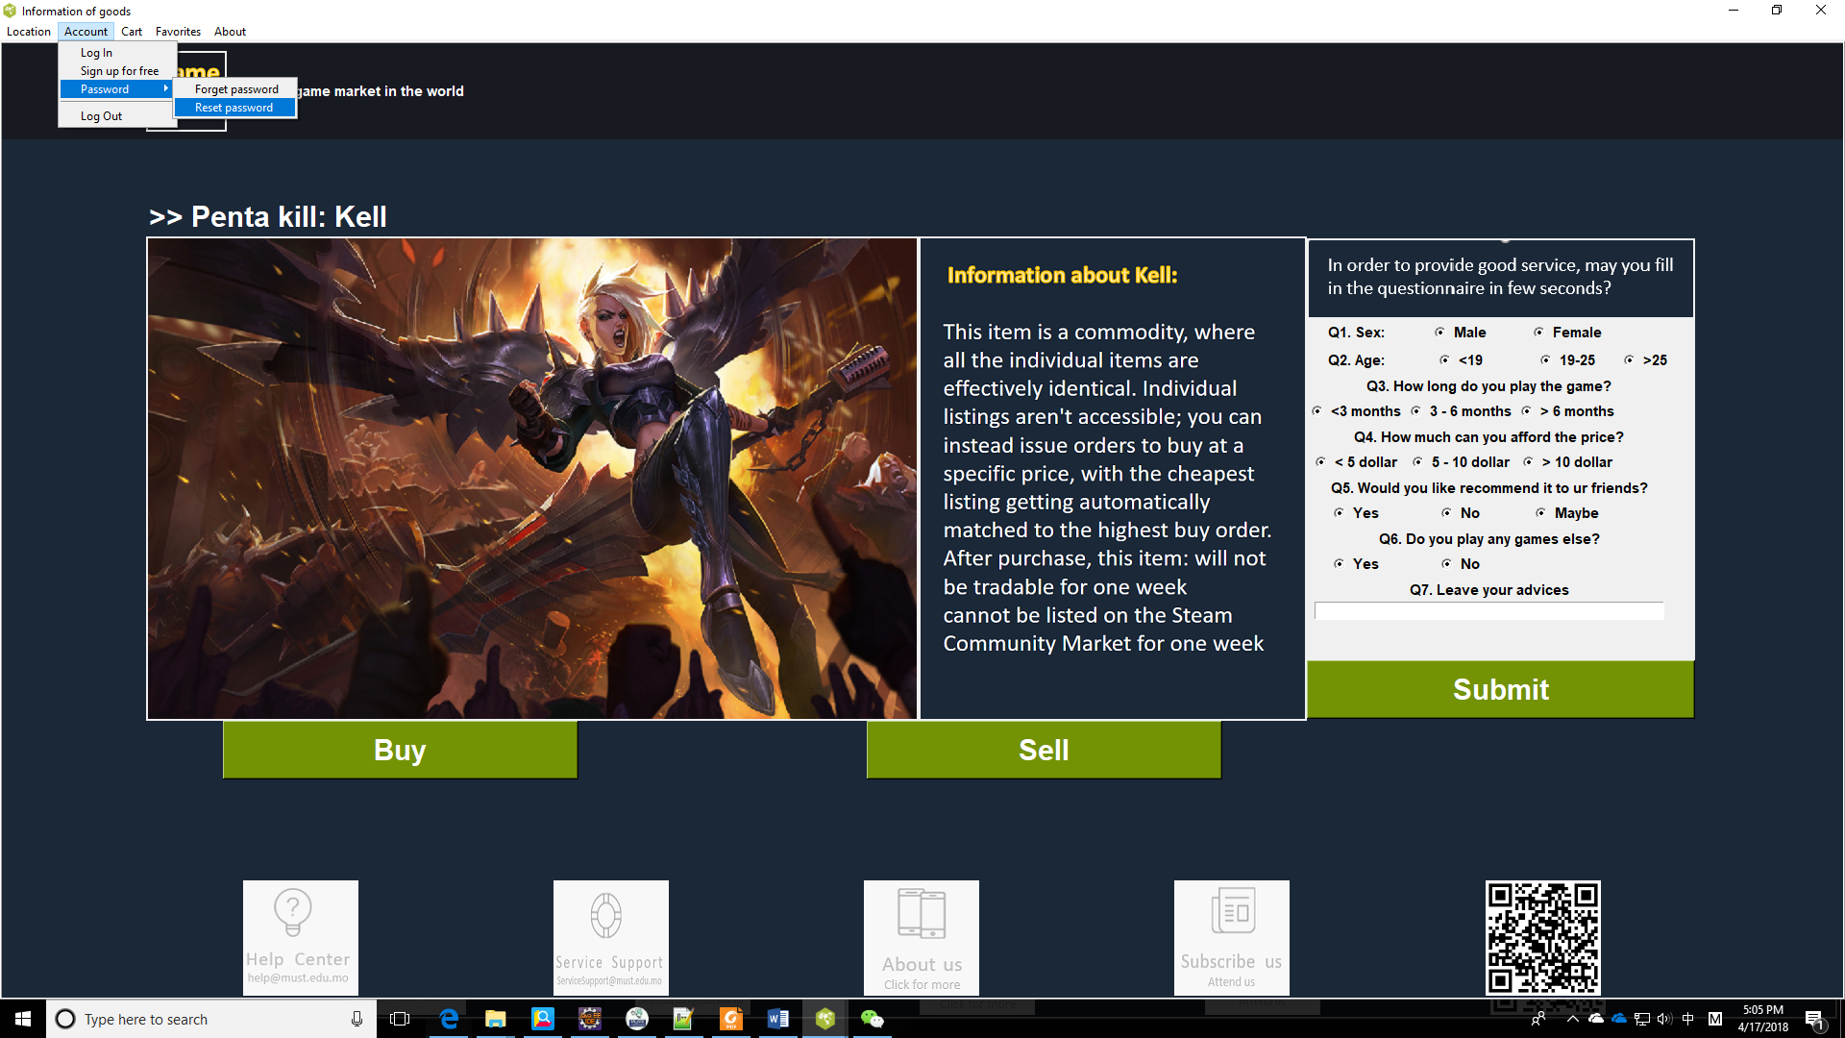

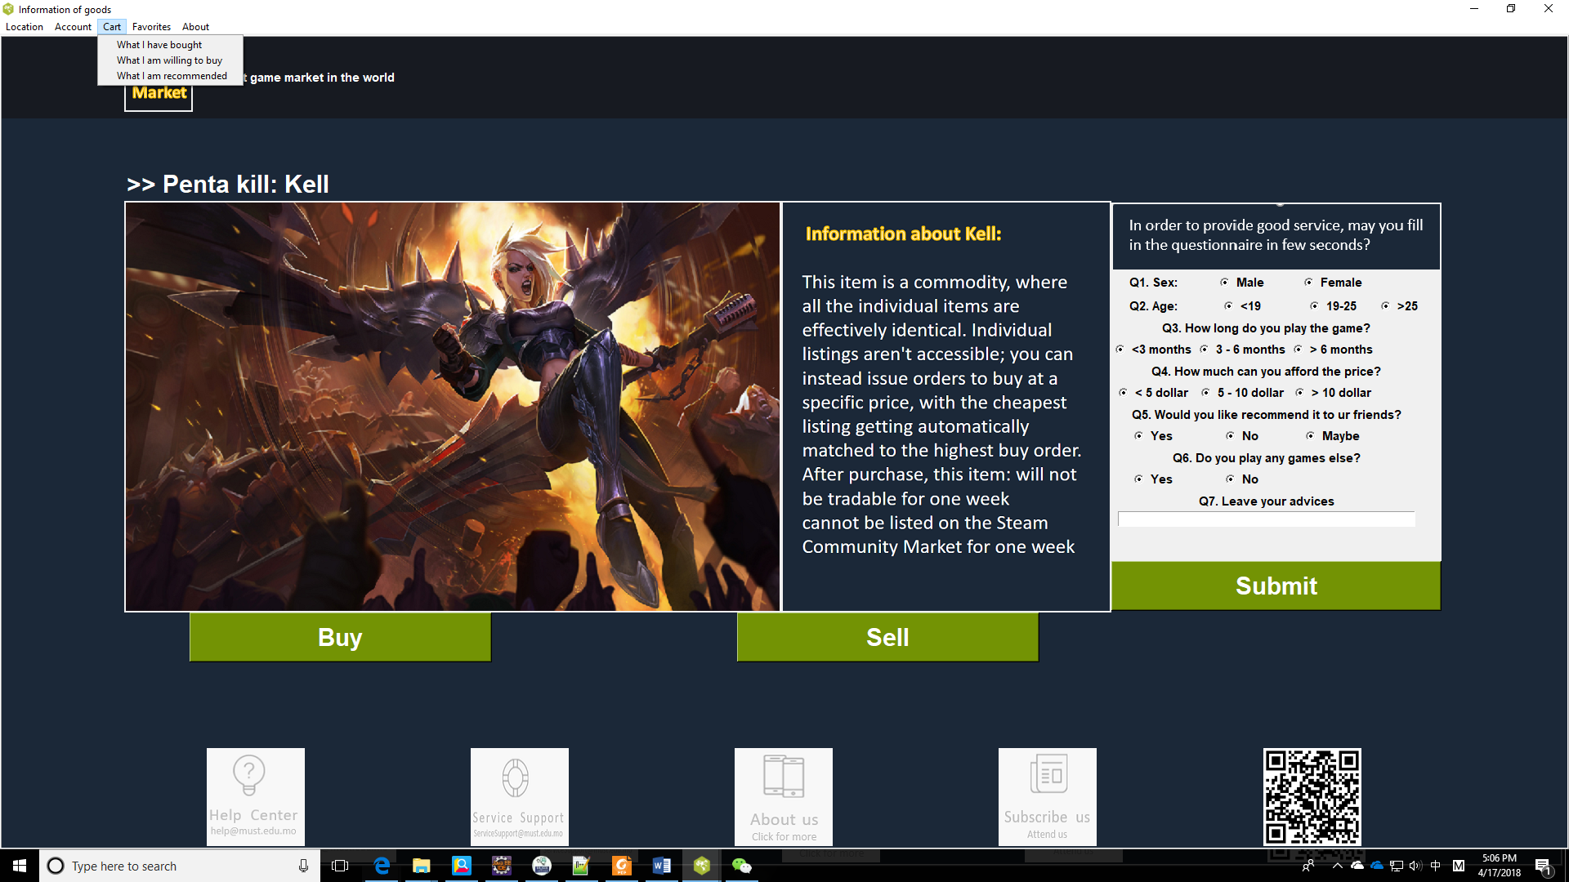

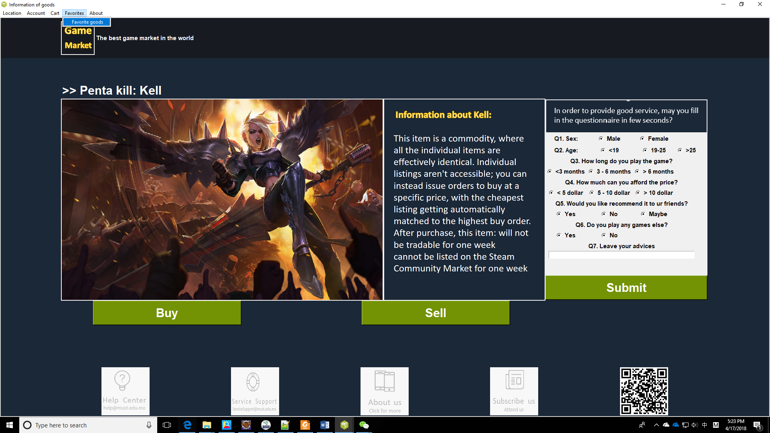

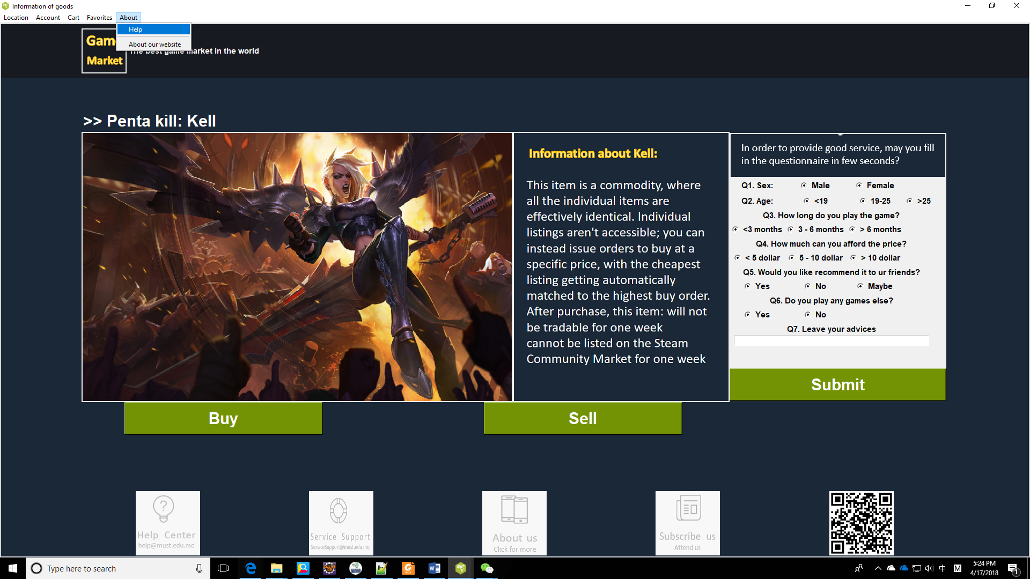

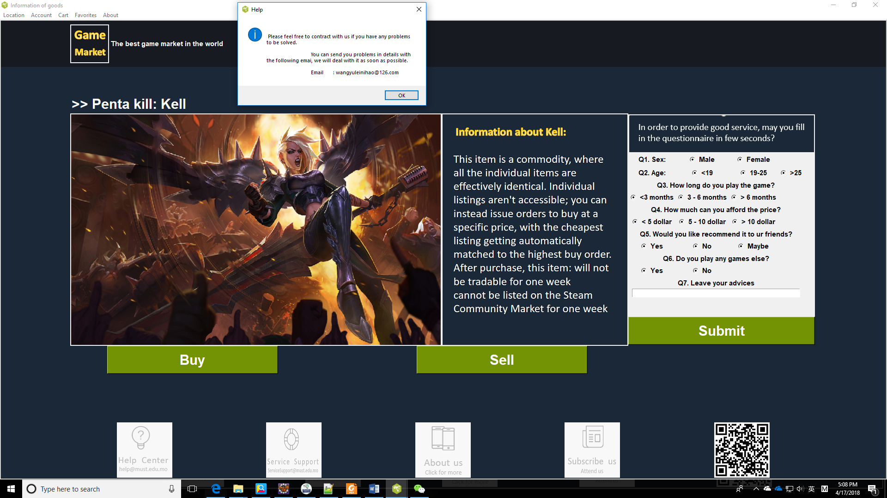

**Log in:**

You can log in the website through this page, if you do not have an account, you can register a new account.

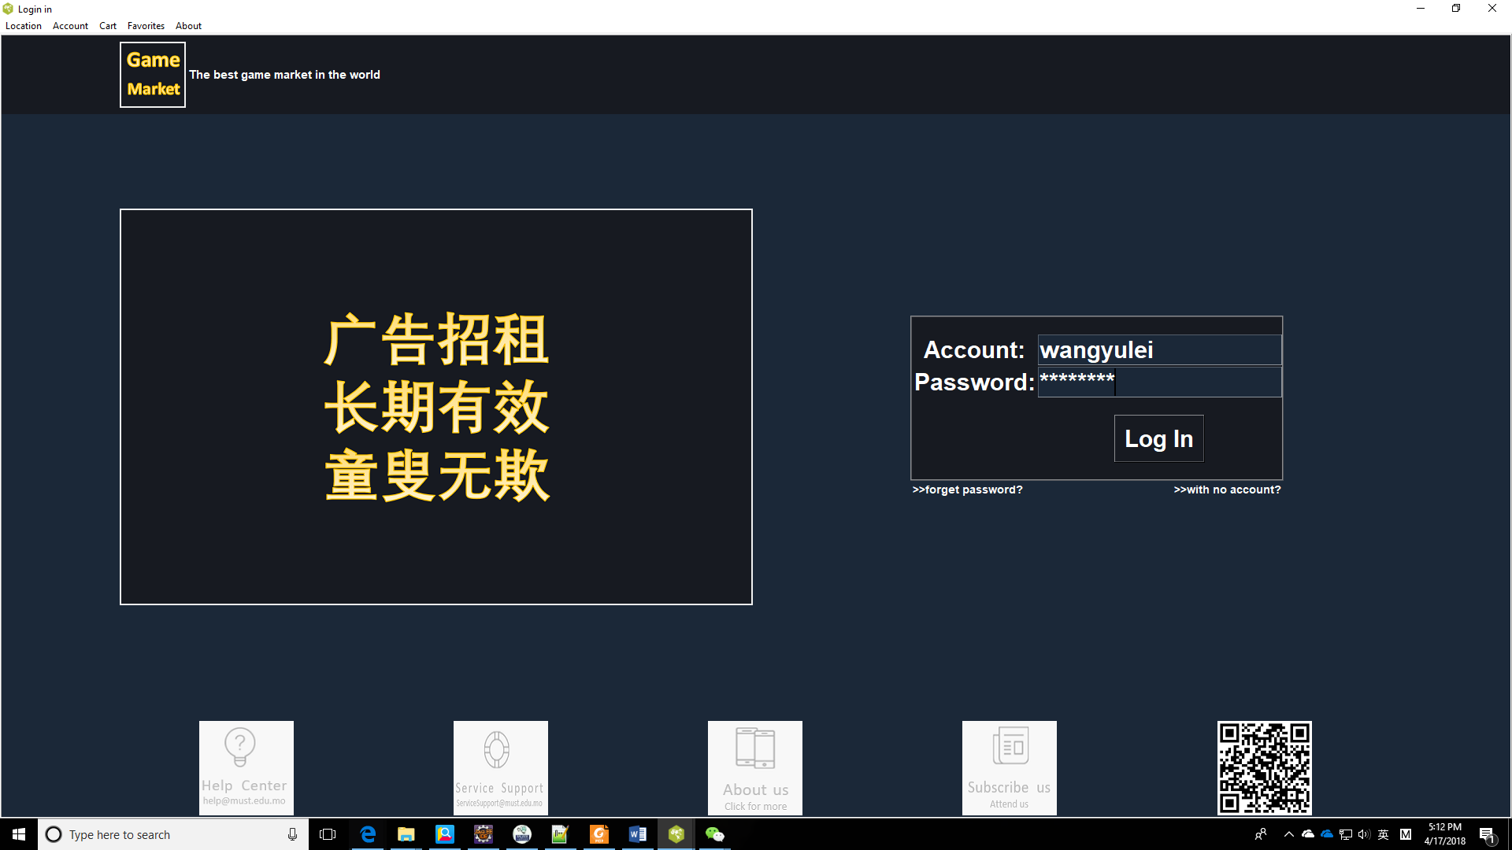

**Sign up:**

You can register a new account through this page.

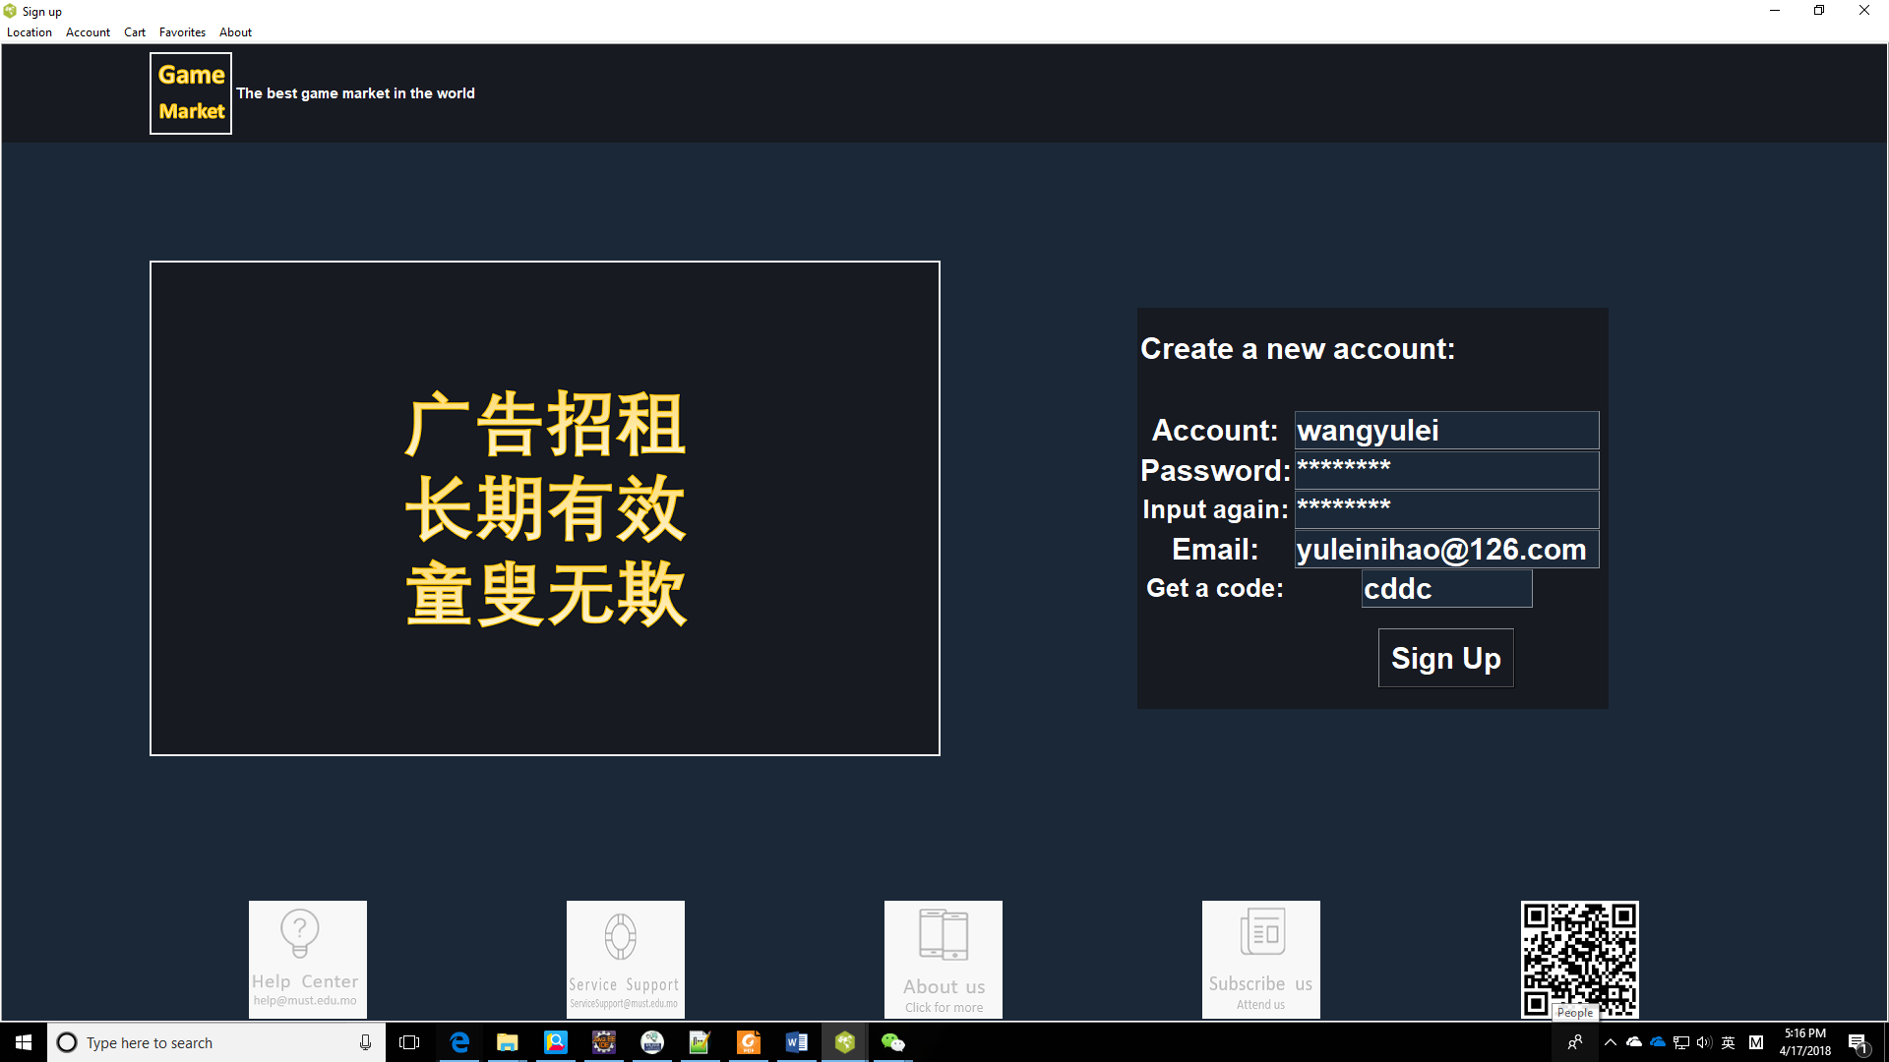

**Information of goods:**

You can know more information about the good you want to buy/sell. If you are interested in the game, welcome to fill in the questionnaire.

